Name: Pranali Sonawane
Subject: MCSA
Date: 24-12-2025
Lab 18: Firewall

Turn on the Firewall on for Server 1, Server 2 and Client 1 and verify connectivity by pinging server 1, server 2 and client 1.
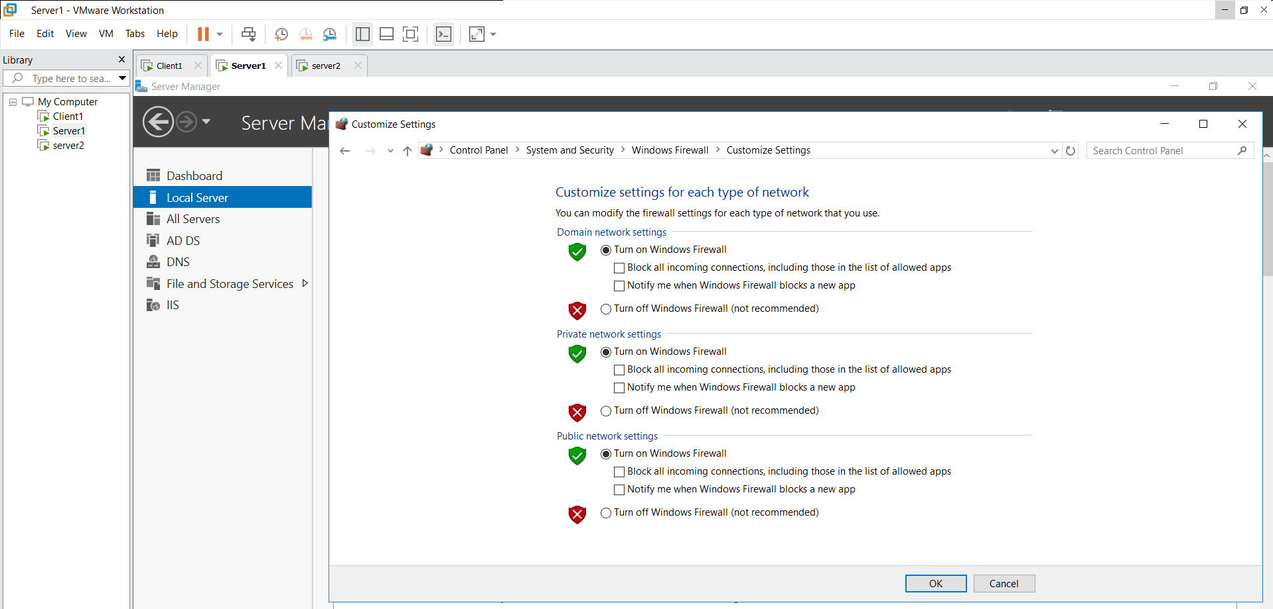
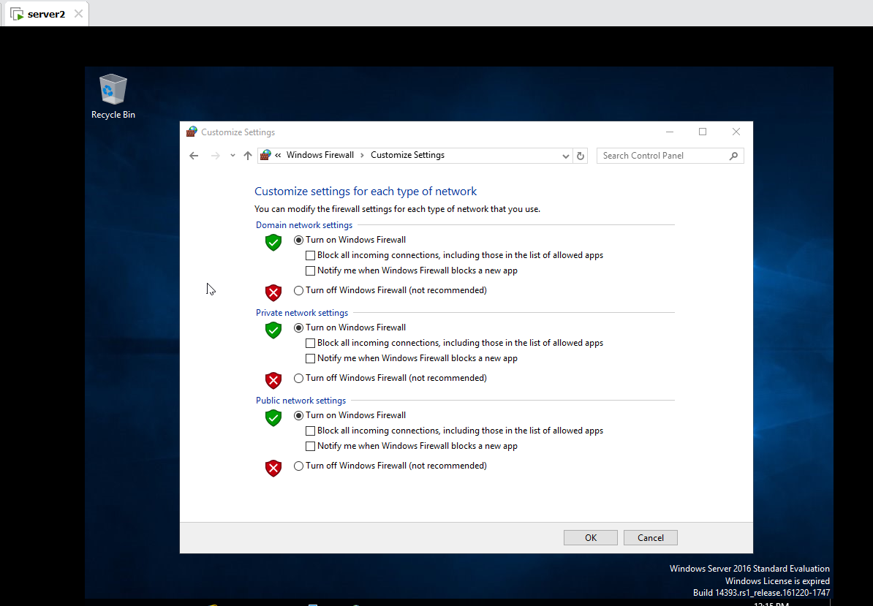
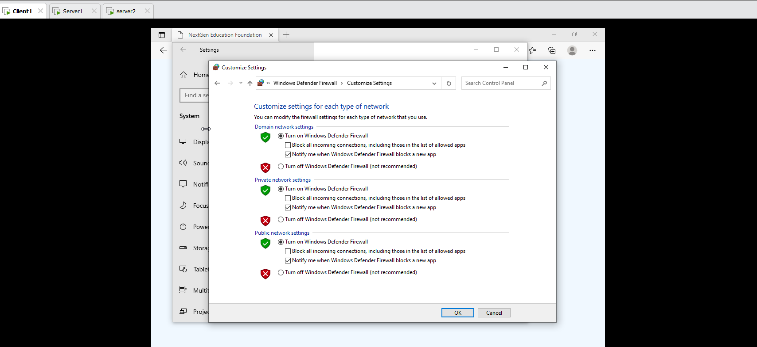
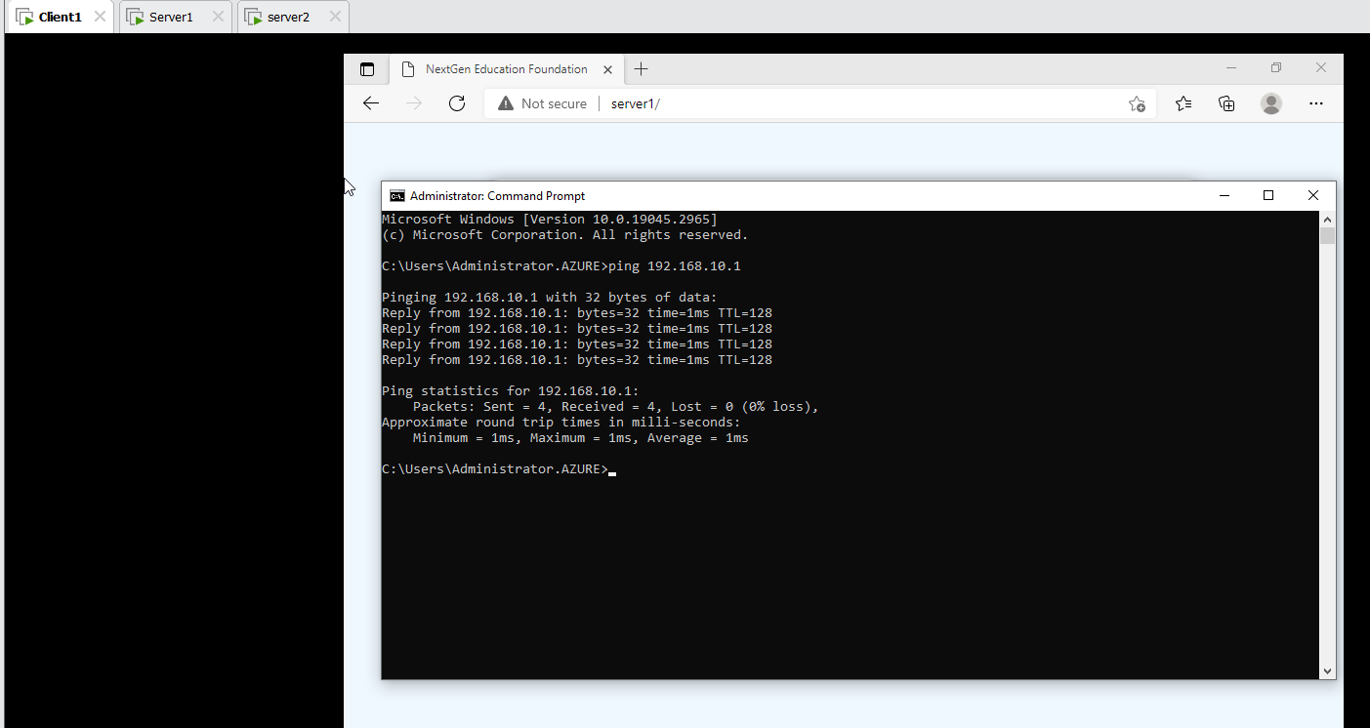
Task:
Ping traffic from Server 1 to Server2 is blocked by the firewall.
Tool Windows Firewall with Advanced Security right click on Active Directory Domain Controller – Echo Request Properties select Action Block the Connection Apply and Ok
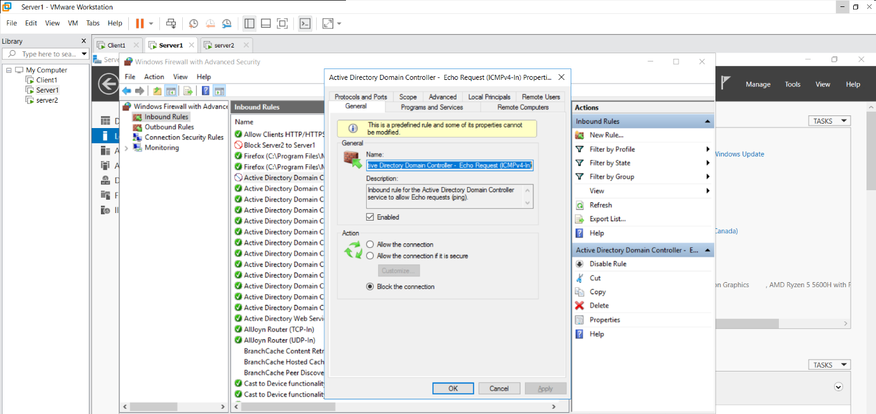
In Server 1 is blocked:
Check Client1 in that ping 192.168.10.1 is blocked
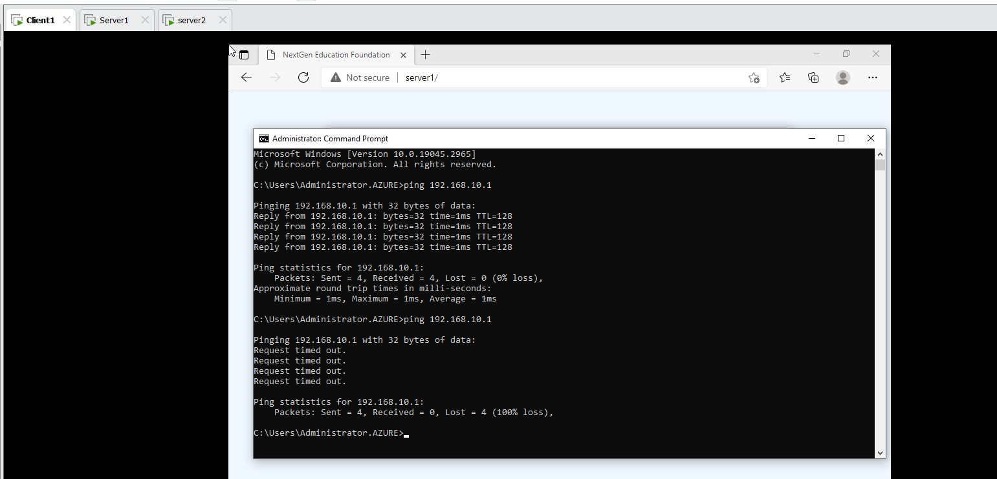
Check Server 2 in that ping 192.168.10.1 is blocked
